**Carbon and ESG Drivers Regulations and Alignment**

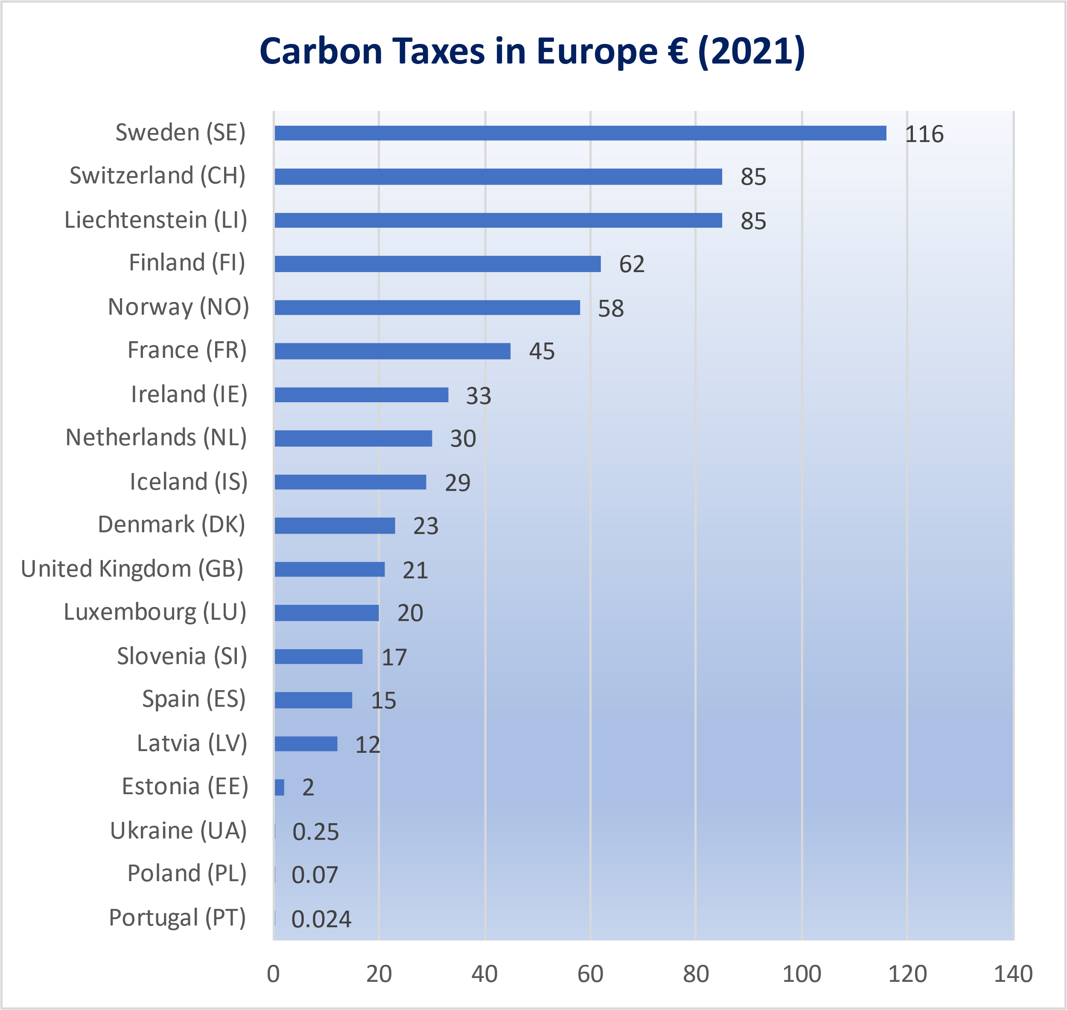

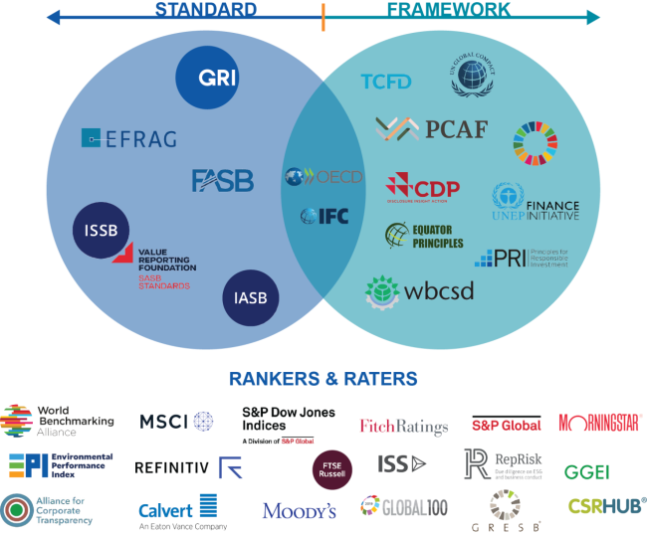

<https://www.3blmedia.com/news/credibility-through-accountability-gri-sets-standard>

**DRIVERS, REGULATIONS, LEGISLATION AND FINANCIAL INCENTIVES**

**EU European Sustainability Reporting Standards ESRS**

The European Union (EU) has issued a set of 13 exposure drafts of European Sustainability Reporting Standards (ESRSs) for companies located in EU member states. These standards would introduce extensive new disclosure requirements and would apply to most listed and large companies located in the EU, including ‘large’ (as defined) European subsidiaries of foreign parent companies.

Legislative procedures are still in process but current proposals aim for initial application for reports published on or after 1 January 2025, with a requirement for limited assurance initially and reasonable assurance after six years.

<https://www.efrag.org/lab3?AspxAutoDetectCookieSupport=1>

**EU Corporate Sustainability Reporting Directive**

What are the new rules?

The corporate sustainability reporting directive amends the 2014 non-financial reporting directive. It introduces more detailed reporting requirements and ensures that large companies are required to report on sustainability issues such as environmental rights, social rights, human rights and governance factors.

The CSRD also introduces a certification requirement for sustainability reporting as well as improved accessibility of information, by requiring its publication in a dedicated section of company management reports.

The European Financial Reporting Advisory Group (EFRAG) will be responsible for establishing European standards, following technical advice from a number of European agencies.

Who will be covered by the directive?

EU rules on non-financial information apply to all large companies and all companies listed on regulated markets. These companies are also responsible for assessing the information at the level of their subsidiaries.

The rules also apply to listed SMEs, taking into account their specific characteristics. An opt-out will be possible for SMEs during a transitional period, meaning that they will be exempted from the application of the directive until 2028.

For non-European companies, the requirement to provide a sustainability report applies to all companies generating a net turnover of €150 million in the EU and which have at least one subsidiary or branch in the EU. These companies must provide a report on their ESG impacts, namely on environmental, social and governance impacts, as defined in this directive.

Who ensures the quality of reporting?

Reporting must be certified by an accredited independent auditor or certifier. To ensure that companies comply with the reporting rules, an independent auditor or certifier must ensure that the sustainability information complies with the certification standards that have been adopted by the EU. The reporting of non-European companies must also be certified, either by a European auditor or by one established in a third country.

From what date will the rules apply?

The application of the regulation will take place in three stages:

1 January 2024 for companies already subject to the non-financial reporting directive

1 January 2025 for large companies that are not presently subject to the non-financial reporting directive

1 January 2026 for listed SMEs, small and non-complex credit institutions and captive insurance undertakings

[**https://www.consilium.europa.eu/en/press/press-releases/2022/06/21/new-rules-on-sustainability-disclosure-provisional-agreement-between-council-and-european-parliament/**](https://www.consilium.europa.eu/en/press/press-releases/2022/06/21/new-rules-on-sustainability-disclosure-provisional-agreement-between-council-and-european-parliament/)

**The International Sustainability Standards Board (ISSB )**

The proposals―exposure drafts—build upon the recommendations of the Task Force on Climate-Related Financial Disclosures (TCFD) and incorporate industry-based disclosure requirements derived from SASB Standards.

When the ISSB issues the final requirements, they will form a comprehensive global baseline of sustainability disclosures designed to meet the information needs of investors in assessing enterprise value. The ISSB is working closely with other international organisations and jurisdictions to support the inclusion of the global baseline into jurisdictional requirements

[The ISSB is seeking feedback on the proposals over a 120-day consultation period closing on 29 July 2022](https://www.ifrs.org/content/ifrs/home/projects/open-for-comment.html) It will review feedback on the proposals in the second half of 2022 and aims to issue the new Standards by the end of the year, subject to the feedback.

[**https://www.ifrs.org/news-and-events/news/2022/03/issb-delivers-proposals-that-create-comprehensive-global-baseline-of-sustainability-disclosures/**](https://www.ifrs.org/news-and-events/news/2022/03/issb-delivers-proposals-that-create-comprehensive-global-baseline-of-sustainability-disclosures/)

**UK Climate Transition Plans (Under TCFD)**

**Regulatory Context**

The Chancellor announced new Sustainability Disclosure Requirements (SDR) at his Mansion House speech in July 2021. In October 2021, the UK Government published a Roadmap for delivering the UK’s strategy to green the financial system, including further detail on SDR.

At COP26 in November 2021, the Chancellor announced that the government and regulators will move towards making it mandatory for firms to publish their transition plans. As part of this, the Financial Conduct Authority (FCA) is requiring certain financial sector firms and listed companies to publish a climate transition plan from 2023, under the TCFD reporting framework. This will encourage more widespread adoption of published plans and increase the need for standards enabling consistency and comparability.

[**https://transitiontaskforce.net/about/**](https://transitiontaskforce.net/about/)

**SFDR -** The Sustainable Finance Disclosure Regulation (SFDR) imposes mandatory ESG disclosure obligations for asset managers and other financial markets participants with substantive provisions of the regulation effective from 10 March 2021. <https://assets.kpmg/content/dam/kpmg/ie/pdf/2021/03/ie-sustainable-finance-disclosure-reg-sfdr.pdf>

**EU Low Carbon Benchmark Regulations** –

“The EU Low Carbon Benchmark Regulation requires administrators of benchmarks (other than interest rate and FX) to comply with new requirements to disclose ESG factors in their methodology documents and benchmark statements. The delegated regulations ((EU) 2020/1816 and (EU) 2020/1817) for ESG disclosure (“Delegated Regulations”) are effective as of Dec. 23, 2020. EU LOW CARBON BENCHMARK REGULATION 1. What are the regulations, and what do they aim to achieve? The EU Low Carbon Benchmark Regulation amends the EU Benchmark Regulation in two ways: first, it introduces two new benchmark classifications—EU Climate Transition Benchmarks (EU CTB) and EU Paris-Aligned Benchmarks (EU PAB)—and second, it requires administrators of ESG benchmarks to publish certain information. Administrators of benchmarks that pursue ESG objectives must (i) publish an explanation of how key elements of the methodology reflect ESG factors; and (ii) explain in the benchmark statement how ESG factors are reflected for each benchmark or family of benchmarks. The aims of the Delegated Regulations are to: • Create a common framework of requirements that promotes consistency, leading to greater comparability between benchmarks; • Clearly state if a benchmark pursues ESG objectives, helping investors to identify them; and • Generate greater transparency of a benchmark’s objectives to help investors understand them more easily. 2. When did the Delegated Regulations come into effect? The Delegated Regulations are effective as of Dec. 23, 2020. 3. Where does the EU Low Carbon Benchmark Regulation originate from? The European Commission published its action plan for financing EU sustainable growth in March 2018. 1 A primary objective of the sustainable finance action plan is to channel private investment into the transition to a climate-neutral economy. One of the initiatives that the EU has implemented to help achieve this goal is the amendment of the EU Benchmark Regulation. This amendment enhances the ESG transparency of benchmark methodologies and specifies minimum methodology standards for low carbon benchmarks in the EU. 4. What are the disclosures required by the Delegated Regulations? The EU Low Carbon Benchmark Regulation requires benchmark administrators to make ESG disclosures in two separate documents: the benchmark methodology and the benchmark statement. In addition, the Delegated Regulations mandate the use of specific disclosure templates. 1 https://ec.europa.eu/info/publications/sustainable-finance-renewed-strategy_en. Register to receive our latest research, education, and commentary at on.spdji.com/SignUp. EU Low Carbon Benchmark Regulation FAQ 2 a. Explanation on how ESG factors are reflected in the benchmark methodology: 2 Administrators of ESG benchmarks are required to use a specific template, to be appended to the benchmark methodology, to disclose information, such as whether the benchmark methodology takes ESG factors into account and if so, which ESG factors are considered and how. The disclosures also require a description of the sources of ESG data used by the methodology, such as whether the data are provided by internal or external sources and whether the data are modeled or reported. b. Explanation in the benchmark statement on how ESG factors are reflected in each benchmark: 3 Administrators of ESG benchmarks are also required to append a specific template to each benchmark statement with information, such as whether the series of benchmarks governed by the benchmark statement take ESG factors into account and if so, which ESG factors are considered and how; whether the series of benchmarks contain any EU CTBs or EU PABs; the disclosure of specified index-level ESG metrics for the benchmark’s asset class; information on the source of ESG data used by the methodology like whether the data are provided by internal or external sources and whether the data are modeled or reported. There is significant overlap between the disclosures required to be made in the methodology document and the benchmark statement. c. Disclosures for EU CTBs and EU PABs: For benchmark statements containing any EU CTBs or EU PABs, additional disclosures are required: the forward-looking year-onyear decarbonization trajectories; the extent to which the benchmarks have achieved the levels of decarbonization required by the minimum standards set for EU CTBs and EU PABs; the level of active share for each EU CTB or EU PAB; the alignment of the benchmarks with the greenhouse gas emissions reductions and objectives of the Paris Agreement; and information regarding the climate models, temperature scenarios, data sets, and methodology used to measure the alignment of the benchmarks with their required decarbonization trajectory. The Delegated Regulations allow benchmark administrators to provide data, such as the ESG and EU CTB- or EU PAB-specific index-level metrics in other formats, such as in files or documents provided via a public-facing website. 5. Which benchmarks need to have these disclosures? All benchmarks4 are subject to the ESG disclosure requirements. In addition, administrators must also use the specified templates for non-ESG benchmarks. Note that non-EU administrators have until Dec. 31, 2021, 5 to comply with the EU Benchmark Regulation. 2 Commission Delegated Regulation (EU) 2020/1817 is available via https://eur-lex.europa.eu/legalcontent/EN/TXT/?uri=uriserv%3AOJ.L_.2020.406.01.0012.01.ENG&toc=OJ%3AL%3A2020%3A406%3ATOC. 3 Commission Delegated Regulation (EU) 2020/1816 is available via https://eur-lex.europa.eu/legalcontent/EN/TXT/PDF/?uri=CELEX:32020R1816&from=EN. 4 As defined in Article 3(1)(3) Regulation (EU) 2016/1011. 5 Article 51(5) of the EU Benchmark Regulation. The third country transition period is expected to be extended until Dec. 31, 2023. EU Low Carbon Benchmark Regulation FAQ 3 6. Where can I find out more information about the EU Low Carbon Benchmark Regulation and the EU Benchmark Regulation? The Regulatory Information page on S&P DJI’s website contains more information on the EU Benchmark Regulation. On this page there is also an area with resources relating to the EU Low Carbon Benchmark Regulation.

<https://www.spglobal.com/spdji/en/documents/education/faq-spdji-eu-low-carbon-benchmark-regulation.pdf>

**April 2022 – TCFD UK - 1,300 of** the largest UK-registered companies and financial institutions will have to disclose climate-related financial information on a mandatory basis – in line with recommendations from the Task Force on Climate-Related Financial Disclosures. This will include many of **the UK’s largest traded companies, banks and insurers, as well as private companies with over 500 employees and £500 million in turnover**.

**Companies (Strategic Report) (Climate-related Financial Disclosure) Regulations 2021** <https://www.legislation.gov.uk/ukdsi/2021/9780348228519/pdfs/ukdsiem_9780348228519_en.pdf>

“The regulations will apply these disclosure requirements to companies which meet the

following criteria:

(a) UK companies currently required to produce a non-financial information

statement, being companies which have more than 500 employees and have

transferable securities admitted to trading on a UK regulated market,

banking companies or insurance companies (‘Relevant Public Interest

Entities’);

(b) UK registered companies with securities admitted to the Alternative

Investment Market of the London Stock Exchange with more than 500

employees; or

(c) UK registered companies which are not included in the categories above,

which have more than 500 employees and a turnover of more than £500m”

**Companies Act 2006 (Strategic Report and Directors’ Report) Regulations 2013.** Global emissions must be reported, not just those in the UK -“In 2013, regulations were implemented requiring **quoted companies (i.e. companies listed on the London Stock Exchange or equivalent European or US markets) to report on greenhouse gas emissions and also on environmental matters to the extent necessary for**

**understanding of the company’s business**”

<https://www.legislation.gov.uk/ukdsi/2013/9780111540169/contents>

**Frameworks and regulations**

Relentless drivers of the carbon accounting and ESG world - <https://www.cdp.net/en/articles/media/comprehensive-corporate-reporting>

**TCFD** - <https://www.gov.uk/government/consultations/mandatory-climate-related-financial-disclosures-by-publicly-quoted-companies-large-private-companies-and-llps>

“Market impact - TCFD legal requirements –underlined =weblink

These disclosure requirements have been based on the recommendations of the Task Force on Climate-Related Financial Disclosures (TCFD) – a taskforce set up in 2015 by the Financial Stability Board (FSB) to improve and increase reporting of climate-related financial information. The disclosures brings together both the Chancellor’s November 2020 [Roadmap towards mandatory climate related disclosures](https://www.gov.uk/government/publications/uk-joint-regulator-and-government-tcfd-taskforce-interim-report-and-roadmap) and the [Roadmap on new Sustainability Disclosure Requirements](https://www.gov.uk/government/news/chancellor-sets-new-standards-for-environmental-reporting-to-weed-out-greenwashing-and-support-transition-to-a-greener-financial-system), published just last month

non-mandatory guidance to support in-scope companies in their disclosure will be issued before the end of the 2021, following parliamentary scrutiny of the regulations

following widespread stakeholder support and feedback gathered as part of the [UK government .consultation on proposals to require mandatory TCFD-aligned climate-related financial disclosures](https://www.gov.uk/government/consultations/mandatory-climate-related-financial-disclosures-by-publicly-quoted-companies-large-private-companies-and-llps), which ran from March until May 2021, 2 key changes have been made:

firstly, the UK government is introducing **a requirement for qualitative scenario analysis – a powerful tool to support companies in their assessment of climate-related risks and opportunities**

secondly, **the requirements will be more closely aligned with the recommendations of the TCFD, to ensure coherence with associated requirements introduced by the Financial Conduct Authority and the Department for Work and Pensions**

in 2017, the Financial Stability Board’s Taskforce on Climate-related Financial Disclosures (TCFD) set out **a framework of 11 overarching recommendations for disclosure over 4 thematic areas - governance; strategy; risk management; and metrics and target - that could be used by economic actors to provide information** on how they manage material risks and opportunities arising from climate change

today’s announcement brings into force the government’s commitment, announced by the Chancellor of the Exchequer in November 2020, that the UK will become the first country in the world to make Task Force on Climate-related Financial Disclosures (TCFD) aligned disclosures fully mandatory across the economy by 2025, going beyond the ‘comply or explain’ approach. The Chancellor set out a roadmap showing how the government would achieve this by 2025, with most of the measures in place by 2023

the **Companies (Strategic Report) (Climate-related Financial Disclosure) Regulations 2021** are due to be laid on 28 October 2021, with the regulations coming into force for accounting periods starting on or after **6 April 2022** subject to parliamentary scrutiny

this approach is recognised in the green investment chapter of the government’s [Net Zero Strategy](https://www.gov.uk/government/publications/net-zero-strategy) published on 19 October

**MANDATORY GHG / CARBON ACCOUNTING – LEGAL OBLIGATION**

In 2016, the UK implemented the **EU Non-Financial Reporting Directive**. This imposed an obligation on all large companies (not just quoted companies) to include a non-financial information statement in their reports, including information on environmental impact” <https://ec.europa.eu/info/business-economy-euro/company-reporting-and-auditing/company-reporting/corporate-sustainability-reporting_en>

Burgess Salmon advise “In 2013, regulations were implemented requiring quoted companies (i.e. companies listed on the London Stock Exchange or equivalent European or US markets) to report on greenhouse gas emissions and also on environmental matters to the extent necessary for

understanding of the company’s business”

**COMPANY LEGAL OBLIGATION**

**Companies Act 2006 (Strategic Report and Directors’ Report) Regulations 2013.** Global emissions must be reported, not just those in the UK <https://www.legislation.gov.uk/ukdsi/2013/9780111540169/contents>

Emissions of all greenhouse gases:

Companies are responsible for all greenhouse gases as outlined by the Kyoto Protocol <https://unfccc.int/kyoto_protocol> , not just their CO2 emissions. Scopes 1 and 2 only. The reporting requirements are only for direct emissions and indirect emissions from purchased electricity and gas

**STREAMLINED ENERGY AND CARBON REPORTING SECR - FINANCIAL OBLIGATION.**

All UK quoted companies to report on their global energy use in addition to greenhouse gas emissions in their annual Directors’ Report. <https://www.pwc.co.uk/services/audit/stakeholder-assurance/streamlined-energy-and-carbon-reporting.html>

There are also requirements for large unquoted companies and limited liability partnerships to disclose their annual energy use and greenhouse gas emissions and related information

**SCIENCE BASED TARGET INITIATIVE – SBTI** - EXTERNAL VALIDATION SYSTEM

**The standards used by Capgemini** [**https://sciencebasedtargets.org/**](https://sciencebasedtargets.org/)

LEAD THE WAY TO A LOW-CARBON FUTURE Science-based targets provide companies with a clearly-defined path to reduce emissions in line with the Paris Agreement goals.

More than 2,000 businesses around the world are already working with the Science Based Targets initiative (SBTi).

**GRI STANDARDS - HIGHLY REGARDED STANDARD MEASUREMENT APPROACH**

GRI (Global Reporting Initiative) is the independent, international organization that helps businesses and other organizations take responsibility for their impacts, by providing them with the global common language to communicate those impacts. <https://www.globalreporting.org/standards/>

It provides the world’s most widely used standards for sustainability reporting – the GRI Standards.

**EU Carbon Tax - Carbon Border Adjustment Mechanism**

[**https://ec.europa.eu/taxation_customs/green-taxation-0/carbon-border-adjustment-mechanism_en**](https://ec.europa.eu/taxation_customs/green-taxation-0/carbon-border-adjustment-mechanism_en)

**TASK FORCE ON CLIMATE-RELATED FINANCIAL DISCLOSURES TCFD - LEGAL DISCLOSURE REQUIREMENT** [**https://www.fsb-tcfd.org/**](https://www.fsb-tcfd.org/)

TCFD The Financial Stability Board created the Task Force on Climate-related Financial Disclosures (TCFD) to improve and increase reporting of climate-related financial information

Climate change presents financial risk to the global economy. Financial markets need clear, comprehensive, high-quality information on the impacts of climate change

The UK Government has confirmed that large UK-registered companies will have to disclose climate-related financial data from

April 2022. This makes the UK the first G20 country to enshrine the mandate into law, subject to Parliament approval. From 6 April 2022, more than 1,300 of the largest UK-registered companies and financial institutions will have to disclose climate-related financial information on a mandatory basis – in line with the TCFD.

**SUSTAINABILITY ACCOUNTING STANDARDS BOARD-SASB - FINANCIAL INFORMATION DISCLOSURE ESG STANDARD**

SASB Standards guide the disclosure of financially material sustainability information by companies to their investors. Available for 77 industries, the Standards identify the subset of

environmental, social, and governance (ESG) issues most relevant to financial performance in each industry. <https://www.sasb.org/>

**ISO 14064 - INTERNATIONAL STANDARD**

ISO 14064-1:2018 <https://www.iso.org/standard/66453.html>

Greenhouse gases — Part 1: Specification with guidance at the organization level for quantification and reporting of greenhouse gas emissions and removals

**PCAF - Partnership for Carbon Accounting Financials**

PCAF helps financial institutions assess and disclose the greenhouse gas (GHG) emissions from their loans and investments through GHG accounting. <https://carbonaccountingfinancials.com/>

GHG accounting enables financial institutions to disclose these emissions at a fixed point in time and in line with financial accounting periods. Measuring financed emissions allows financial institutions to make transparent climate disclosures on their GHG emissionexposure, identify climate-related transition risks and opportunities, and set the baseline emissions for target setting in alignment with the Paris Agreement.

**MSCI – ESG RATINGS AGENCY**

External verification of companies ESG – Capgemini is AA which is world leading and we are on track to meet Paris Agreement target of within 1.%C rise. <https://www.msci.com/research-and-insights/esg-ratings-corporate-search-tool/issuer/capgemini-se/IID000000002124071>

**SFDR – The Sustainable Finance Disclosure Regulation (SFDR**)

SFDR imposes mandatory ESG disclosure obligations for asset managers and other financial markets participants with substantive provisions of the regulation effective from 10 March 2021.

<https://assets.kpmg/content/dam/kpmg/ie/pdf/2021/03/ie-sustainable-finance-disclosure-reg-sfdr.pdf>

**SEC IN USA – The Securities and Exchange Commission**

The U.S. Securities and Exchange Commission (SEC) announced proposals - for the first time U.S. companies to provide information on climate risks facing their businesses, and plans to address those risks, along with metrics detailing the companies’ climate footprint including Scope 1, 2 and in some cases Scope 3 greenhouse gas (GHG) emissions.

[**https://www.esgtoday.com/the-sec-unveils-long-awaited-proposed-climate-disclosure-rules/**](https://www.esgtoday.com/the-sec-unveils-long-awaited-proposed-climate-disclosure-rules/)

SEC Announces Enforcement Task Force Focused on Climate and ESG Issues. Washington D.C., March 4, 2021 — The Securities and Exchange Commission today announced the creation of a Climate and ESG Task Force in the Division of Enforcement.

<https://www.sec.gov/sec-response-climate-and-esg-risks-and-opportunities>

**ESG means environmental social and governance** – this underpins sustainability. It was really started by the late great Kofi Annan in 2000 when he was UN Secretary General <https://www.equanimityinvestments.com/newsletter/esg-for-dummies>

**Carbon Accounting** really grew formally from the Rio UN Summit in 1992, although as we discussed carbon dioxide as a greenhouse gas was known and climate change for decades. <https://sustainabledevelopment.un.org/content/documents/1127rioprinciples.pdf>

**Climate Change Act 2008**

In 2019 the Government amended the Climate Change Act to commit the UK to achieving net zero ( 100%) by 2050, compared to the previous target of an 80% reduction in emissions by 2050

This is monitored by the Committee on Climate Change - <https://www.theccc.org.uk/> - legally binding.

**GLASGOW CLIMATE PACT**

<https://ukcop26.org/wp-content/uploads/2021/11/COP26-Presidency-Outcomes-The-Climate-Pact.pdf>